|  |  |  |  |  |  |  |  |
| --- | --- | --- | --- | --- | --- | --- | --- |
|  | |  | |  | |  | |
|  | |  | |  | |  | |
|  |  | |  | |  | |

**Requirements Gathering Inception Report**

**For**

**Ministry of Gender Labour & Social Development**

**14 June, 2021**

 

Contents

Acronyms 3

Acknowledgments 4

Executive Summary 5

Introduction 5

Scope 6

Requirements Gathering Participants 8

Day 1 8

Day 2 8

Day 3 8

Summary of Key Findings 9

Summary table of requirements. 9

Other Findings and Recommendations 11

Infrastructure 11

Hardware Findings 12

Operations and Roles 13

Partners UNFPA and UNICEF 13

Administrator 13

Counsellor 13

Supervisor 13

Case Manager 14

Case Worker 14

Case Escalation Process 14

Case Categories 14

Mobile App 15

Web Information Page 15

Reporting Module 15

Pivot Reports 16

Comprehensive Reports 16

Proposed Process Flows 17

Call process flow 17

Case Capture process Flow. 18

Additional Feature 19

Conclusion 20

Appendix 1: Proposed Web-Online Form 21

Appendix 2: Proposed Case Categories 23

# Acronyms

GBV Gender Based Violence

VAC Violence Against Children

FRD Functional Requirements Document

ACHT Average Call Handling Time

TAT Turn Around Time

QC Quality Control

MNO’s Mobile Network Operators

LAN Local Area Network

UPS Uninterrupted Power Supply

NITA National Information Technology Authority

BITZ ITC Bitz IT Consulting Ltd

# Acknowledgments

The BITZ ITC team would like to express our gratitude to all who took the time to speak to us during this exercise, particularly representation for the Government of Uganda under the Ministry of Gender Social and Labor Development, NGBV, Sauti Child Helpline, UNFPA and UNICEF Uganda.

We were able to conduct one on one interviews with various stakeholders at the Ministry of Gender, Labour and Social Development and at the Sauti Helpline. Because of this support Bitz ITC team always felt that we were in a position to achieve more over the requirements gathering period. At the same time, we accept responsibilities for any errors, omissions or misunderstandings in this report.

# Executive Summary

## Introduction

The Uganda Child Helpline (UCHL) established in 2013 is an important tool for child protection that gives thousands of children across the country an opportunity to be heard and have their lives changed for better. The UCHL is currently providing a series of services including; i) Telephone response to cases of Violence against Children (VAC) through the toll-free number 116; ii) Management of cases reported through; various media platforms, U-report and Walk-in clients; ii) Follow-up of cases of Online Child Sexual abuse, and; iv) Community awareness raising campaigns in schools, communities, on radio and television.

On average, the Helpline receives 750-800 calls per week which translate to 30 – 40 cases a day. The category of cases reported include child labour, child neglect, emotional abuse, child trafficking, physical abuse and sexual abuse among others. The reported cases are handled through a case management process that has case workers deployed at the Helpline and also District Action Centers in the Districts that work closely and have linkages to the Police, Community Development Officers, Probation and Social Welfare Officers, Civil Society Organizations among others. The Ministry through the Department of Gender and Women Affairs is mandated to address gender and women concerns which include the elimination of Gender Based Violence (GBV). Despite significant achievements registered towards prevention and response to GBV in Uganda, its prevalence is still exceptionally high. The Ministry wishes to focus and address Gender Based Violence through the SAUTI Helpline to enable immediate response and case management through the national and sub national structures.

The Ministry of Gender, Labor and Social Development therefore has requested UNFPA to support the upgrade of the current SAUTI Helpline to integrate cases of the Uganda Child Helpline to support the online reporting and management of GBV cases. This will be a joint partnership between MGLSD, UNICEF and UNFPA; where UNFPA provides the financing for the consultancy and manage the contract. MGLSD and UNICEF will together with UNFPA provide technical assistance to the consultant to deliver on the assignment.

This documentation presents preliminary requirements to the upgrade of Sauti Helpline System to integrate GBV (Gender Based Violence) case reporting and improved integrations with other government and non-governmental systems in the circle of child protection and GBV cases.

# Scope

The upgrade should put the following into consideration:

1. The system should be able to receive calls for both GBV and VAC on the toll free number 116 through an E1 channel (*With agents set for respective queue based on respective specialization*).
2. The system should be developed based on open source standards and technologies preferably on major frameworks such as Laravel, Django, Spring e.t.c. The process shall be managed and code shared on a code repository such as Github with clear documentation on deployment and integrations.
3. Build capacity of the end user teams to be able to make minor adjustments to the system (configurable modules where possible e.g case categories, SIP accounts,) and to manage the system after it has been handed over.
4. Develop a universal documented API to enable integration with other 3rd Party systems including:
   1. Single Registry of Social Protection(Mandatory)
   2. The NGBVD
   3. GBV Shelters
   4. Safe Pal (Mandatory)
   5. Uganda Police Information System
   6. Health Information System
   7. Education Management Information System (EMIS)
   8. Courts of Law
   9. Others as may be specified during the consultation/development process.

API will enable a secure integration with any systems. As it will expose data for consumption in two-ways. External systems will be allowed to consume data from the CHL; the CHL will also be able to access and use data produced by other systems.

1. The solution should be able to handle case distribution, routing, escalation based on roles & permissions regarding access for reported GBV and VAC cases. This should include follow-ups, case prioritization as well as case closure by providing necessary assistance to the clients who reach out to the Call Center for both GBV and VAC cases.
2. The solution is expected to be multi-channel including: voice, SMS, U-Report, WhatsApp, Web-Online and Tweet-CHAT with ability to provide distributed and remote terminals.
3. Provide dashboard real time call and case analytics which include sex, age, disability status & nationality/refugee status for Counsellors, Supervisors, Case Managers and Case Workers as well as Performance Management Data based on Key Performance Indicators (KP Is) for individual agents and the help desk as a whole for both GBV and VAC cases.

NB: Case managers include: health workers, legal aid providers, psychosocial support and police among others.

1. The solution should be able to generate automated reports disaggregated according to various metrics and indicators (age, sex, disability status, nationality/disability status) on both GBV and VAC
2. The system should allow for capture/entry of GBV /V AC cases (desegregated by age, sex, disability status, nationality/refugee status among others) reported at district level through walk-ins and other means into the system at the District Action Centers/Probation offices.
3. Design and documentations such as:
   1. End-user training manuals, job aids, reference manuals and quick guide reference cards.
   2. Technical system documentation such as system architecture and technical specifications documentation, system manuals including quick troubleshooting guides and summaries, system administration manuals, guides, configuration, backup and restore procedure manuals.
4. The system should be accessible/friendly to users with disability specifically for vision, hearing and motor skill impairments.
5. Plan and conduct training for: Helpline staff, Helpline Supervisors, case managers (as describe in point 7), local helpline GBV’s nominated IT focal points and other relevant staff identified.
6. Provide technical support and ongoing routine maintenance for the Helpline, including regular software updates/upgrades for a period of one year after commissioning of the system.
7. Implement security protocols for call & case data and design & setup remote backup, restore & recovery plans, procedures and systems based on the developed Functional Requirements Document (FRD) taking into consideration confidentiality of the data.
8. Deploy the enhancements on the hosting platform and secure it with a Secure Sockets Layer (SSL) certificate for added security.
9. Allow remote working by providing agents and/or caseworkers not tied down to the office to handle cases through VPN.
10. Develop a public accessible webpage for the Helpline with information dashboards, information about services of the helpline, documentations among others.
11. The solution to have in mind existing data and consider data migration where need be and applicable.
12. Mobile Application This is a data collection and management mobile platform to be used in resource constrained areas and so should leverage on existing open-source data collection frameworks such as ODK for offline capability where possible.
13. Project Management. The solution developers shall report to the project manager under Bitz IT Consulting Limited.

# Requirements Gathering Participants

## Day 1

|  |  |  |  |  |
| --- | --- | --- | --- | --- |
| **Name** | **Title** | **Organization** | **Email** | **Telephone** |
| Nahabi Sarah | Call Center Manager | UCHL/MGLSD | Nahsar2@gmail.com | +256752482859 |
| Tonny Francis Lujaganya | IT Officer | UCHL/MGLSD | lutofra@gmail.com | +256706714790 |
| Antoinette Angwech | Call Center Supervisor | UCHL/MGLSD | angecha@yahoo.com | +256758594994 |
| James Nganga | Director | Bitz ITC | James.nganga@bitz-itc.com | +254720055067 |
| Henry Kemboi | Project Manager | Bitz ITC | Henry.kemboi@bitz-itc.com | +254727647431 |

## Day 2

|  |  |  |  |  |
| --- | --- | --- | --- | --- |
| Name | Title | Organization | Email | Telephone |
| Ngabirano Fred | Commissioner Youth and Children | MGLSD | ngabiranofredo@gmail.com | +256776900049 |
| Nikolaas Swyngedouw | Child Protection Officer | UNICEF Uganda | nswyngedouw@unicef.org | +256772144011 |
| Emmanuel Yeka | Ag. PITO - MGLSD | UCHL/MGLSD | emmanuel.yeka@mglsd.go.ug | +256752482859 |
| Isaac Niwamanya | Systems Administrator | MGLSD | isaac.niwamanya@mglsd.go.ug | +256 774 441126 |
| Brian Masimbi | M&E Officer | MGLSD | bmasimbi@yahoo.com | +256782595799 |
| James Nganga | Director | Bitz ITC | James.nganga@bitz-itc.com | +254720055067 |
| Henry Kemboi | Project Manager | Bitz ITC | Henry.kemboi@bitz-itc.com | +254727647431 |

## Day 3

|  |  |  |  |
| --- | --- | --- | --- |
| Name | Title | Email | Tel. No |
| Angela Nakafeero | Commissioner G/WA - MGLSD | angelanakafeero@gmail.com | +256776831669 |
| Emmanuel Yeka | Ag. PITO - MGLSD | emmanuel.yeka@mglsd.go.ug | +256773510756 |
| John Mugisha | Coordinator /UCHL - MGLSD | gisha2013@gmail.com | +256783639017 |
| Irene Oluka | CPO - UNICEF | ioluka@unicef.org | +256772147065 |
| Lillian Mpabulungi | SOS Children | lillian.ssengooba@sosuganda.org |  |
| Harriet Ndagire | NPPP, GHR - UNFPA | hndagire@unfpa.org | +256772730624 |
| James Nganga | Consultant – Bitz IT Consulting | james.nganga@bitz-itc.com | +254720055067 |
| Charles Etoma | Senior Statistician -MGLSD | etomacharles@gmail.com | +256772971208 |
| Semmy Angeyo | Planning Officer - UNICEF | sangeyo@unicef.org |  |
| Isaac Niwamanya | Systems Admin - MGLSD | Isaac.niwamanya@mglsd.go.ug | +256774441126 |
| Grace Odeke Ikirimat | Programme Analyst - UNFPA | odeke@unfpa.org | +256772923311 |
| Tonny Bbosa | IT Specialist – NITA-U | tonny.bbosa@nita.go.ug | +256774477523 |
| Tonny Lujaganya | IT Officer/UCHL - MGLSD | tonny.francis@mglsd.go.ug | +256775068060 |

# Summary of Key Findings

The team’s efforts during this requirements gathering exercise focused on the status of the current system in use at the Sauti helpline, gathering the GBV requirements and drawing a flawless integration process to accommodate both GBV & VAC case capture and management. Infrastructure requirements have also been identified and solutions proposed.

It was agreed that the development of the new system needs to be undertaken as a matter of urgency for the current system to be improved with capacity to handle both GBV and VAC cases.

It was agreed that the integration will be possible since upgraded GBV/UCHL system will come with an API and the BITZ ITC team would work closely with the all technical teams at the Ministry during the development. The development technologies for both systems are mostly similar further supporting the integration path.

Case categories were also to be harmonized for both GBV and VAC to provide a seamless platform for counsellors to be able to manage cases for GBV and VAC efficiently.

It was also agreed that Web-Online Case registration Form (designed and attached as an Appendix 1.) should be integrated with the Case Management Form. Ideally this would ensure that cases reported through this mode of communication would hit the Helpline system in a structured format.

The helpline has started the process of acquiring E1 links to the Call Center. However of all the Telkom service providers only MTN has laid the cable to the Call Center. The process to get the other providers to provide this service needs to be worked on urgently while MTN need to do termination work of their E1 cable.

Both of these issues need to be resolved before the deployment of the new system. Since there are procedures and approvals required, it is important that the process is started as early as possible.

It was agreed that one form for both GBV and VAC will be used in Case capture. The consultant will use their experience as well as the existing form and details provided by GBV to design a comprehensive form that will entail all details and eventually enable effective response and reporting for both departments at National level and all other lower levels.

## Summary table of requirements.

|  |  |  |
| --- | --- | --- |
|  | **Problem** | **Proposed Solution** |
| 1 | Call Capacity at the Helpline with addition of GBV calls | Upgrade of GSM technology to E1 or SIP which can handle more concurrent calls |
| 2 | Number of resources with increased volume of calls | Recruitment of more resources to manage the call volumes at the Call Center |
| 3 | Knowledge on handling of both GBV and VAC calls | Training and Capacity building required as a key component for the success of this project at National and District levels |
| 4 | Case categories | Harmonization work to be done and provide as much options in the Case Capture Form  GBV to work with VAC and the consultant to harmonize the Case categories in the form. |
| 5 | How to differentiate between GBV and VAC cases including reporting Provide ways of dealing with Intertwined cases which have both GBV and VAC components | Age suggested as the key for this differentiation as Categories will be harmonized.  0-4  5-17  18-30 Youth  31-60 Adult  61 and Above Older |
| 6 | Offline Case Capture with no Internet Connectivity | Mobile App for tablets and Smart Phones developed with ability for offline case capture and synchronization when internet becomes available |
| 7 | Integration to other systems including NGBVD | Integrations will be possible as consultant will provide an API. Stakeholders including NITA and Ministry have pledged support to the consultant for required integrations. |
| 8 | Be able to generate reports based Case status e.g. Pending cases, Closed Cases, Escalated Cases | Exists in the current VAC system and will be provided in the upgraded UCHLGBV system |
| 9 | Provide View rights to partners including UNFPA and UNICEF | This will be provided in the upgraded UCHLGBV system |
| 10 | In Categorization of cases let us have Nationality | Will be provided in the upgraded UCHLGBV system |
| 11 | For IVR if possible let us have Language selection maybe a few of the major languages | The Ministry will provide the recorded IVRs and the consultant will inbuilt it in the system |
| 12 | Social media reporting platform not integrated with the CRM | The function will be added in the upgraded system |
| 13 | Classification of case categories to fit the reporting of cases to the DCS | Adopt the standardized case categories in the CPIMS |
| 14 | Referral and feedback mechanism not working | More integrations to government systems envisaged and referrals expected to be more effective in the upgraded system. |
| 15 | The client experience long queuing before their call is picked. | Increase capacity in the call center |
| 16 | The case form popping is not reliable for it at times does not respond | The new system should address the problem |
| 17 | System slows down during the pulling of reports | The infrastructure should be improved to be able to handle heavy workload. Upgrade of the system will make report generation more efficient. |
| 18 | Inability to customize reports | Allow customizing of reports in the upgraded system. |
| 19 | Online case reporting not existing | Web Online form case registration will be added to the Ministry website and integrated to the Case Management System. |

# Other Findings and Recommendations

## Infrastructure

**Current Infrastructure Setup**

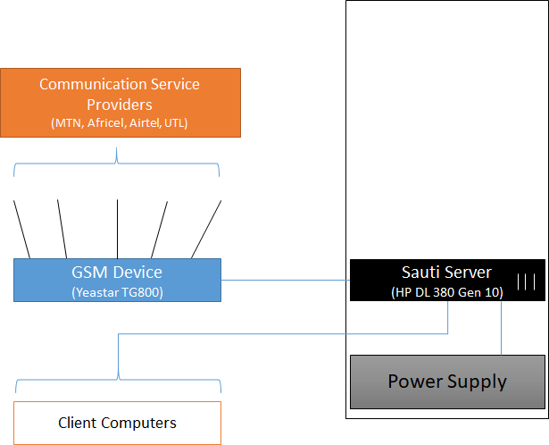

There are 4 Active Telkom service providers terminating GSM technology at the helpline center. The GSM modules are connected through the Yeastar IP PABX device. There is one server that runs the Case Management software as well as the Asterisk PABX software.

**Proposed Infrastructure**

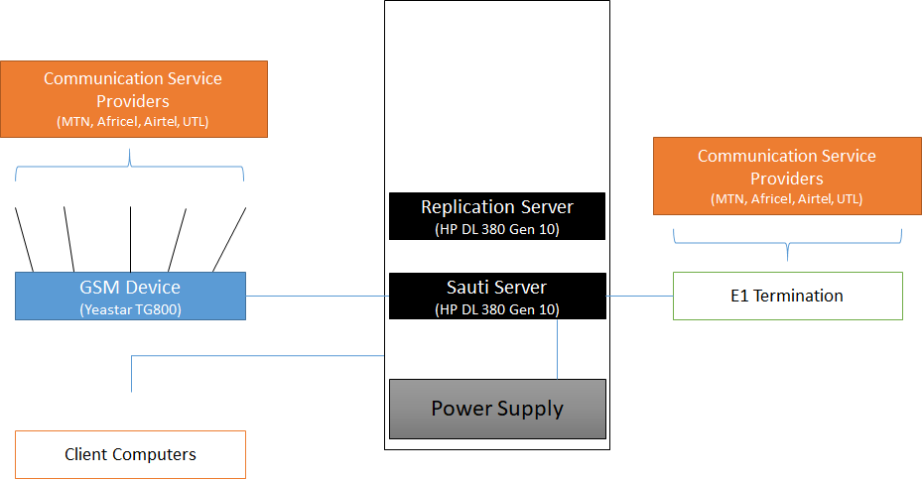

## Hardware Findings

The helpline has a relatively good LAN setup. However the cabinet hosting the switches and patch panels is not tidy. The cabinet needs to be replaced with a bigger one and the termination cleaned up and properly labelled.

Call termination has been done by two most service providers on GSM technologies with only MTN pulling an E1 cable which is also not terminated. In the proposed changes to the infrastructure the Telkom providers will need to terminate to E1’s instead of GSM modules as this technology is more efficient and more stable and can handle more concurrent calls with 32 channels.

It is also proposed that another server be added which will become the primary server and the current server becomes the replication server. Challenges of space have been experienced before hence the additional server needs to have more space and can be complimented by a NAS (Network Attached Storage) to store older call recordings.

The sever room is served by an efficient power backup and when there is a power blackout there is an existing Generator which picks up automatically so there is continuous power flow at the Helpline Call Center.

Below is a table showing some of the challenges faced and the solutions proposed and agreed upon by the team during the requirements gathering meetings.

# Operations and Roles

The system shall have the following user levels: administrator, counsellor/agent, supervisor, case manager and case worker.

Every user level shall dashboard representative of their account roles and activity including statistics of calls and cases based on parameters such as categories, status, gender, districts, priority and any other applicable field. The dashboards will also have graphical displays line & pie charts, bar graphs, etc.

## Partners UNFPA and UNICEF

They will be assigned **View** roles so that they can log-in to the system and anytime and view the activities and statistics at the Helpline as may be required. Mostly they will be given access to view reports from the system.

## Administrator

This is a general system administrator responsible for general system configurations, the can view cases, they have minimal or no action. The following are some of the roles by administrators:

* Create and update configurable parameters such as case categories and services offered.
* Manage system users.
* View reports.

## Counsellor

Counsellor handle calls and are mainly based at the call center. They are trained to offer first-line support for both VAC and GBV. Additionally, they:

* create cases from calls
* escalate cases to supervisors
* view their own cases.
* Can search cases from all cases

## Supervisor

A supervisor is the call center manager who is in charge of counsellor/agent work affairs and to ensure they are within the set policies of the helpline. They:

* Can create cases.
* View all cases with an option to update.
* Perform QA on calls.
* Propose system settings and updates to the administrator.

## Case Manager

The case manager is mainly related to the tasks of a case worker. They:

* Can create case.
* View all cases escalated to them, the cases they create and those created by case workers.
* Assign cases to case workers.

## Case Worker

They are majorly concerned with non-call cases and cases assigned to them by Case Managers. They view only their cases and those assigned by case managers but can search all cases in case of follow up.

# Case Escalation Process

This is the process in which a case goes through before it’s closed. A case may be closed at the time of creation by the counsellor but sometimes it requires attention from a higher level of the user hierarchy.

A counsellor can escalate a case to a supervisor who in turn can escalate the case to a case manager, the case manager assigns cases to case workers who in most of the time are in the field.

After these roles were defined Case capture flow was also discussed. Seven broadly classified tabs for the information to be captured were proposed.

1. Case Reporter Details
2. Case Category
3. Other Client Details
4. Perpetrator Details
5. Case Narrative
6. Services Offered
7. Case Action

Depending on the case status if the client is a first time Reporter the counselor would click on Create New case otherwise if the client is a repeat Reporter/ Client the form should populate their details accordingly.

# Case Categories

This issue had been discussed before between VAC and GBV departments of the MGLSD. After further deliberations during the various requirements gathering meetings, it was agreed that the upgraded Helpline system will try to harmonize Case Categories as much as possible between GBV and VAC.

**Appendix 2** outlines the various proposed Categories for the VAC and GBV which the consultant will continue to work with the stakeholders to harmonize.

# Mobile App

This shall solely be developed for case capture in the fields and remote areas. This shall be an android device application supported on both smart phones and tablets. It shall have an offline case capture capability for the sake of area with minimal infrastructure that would otherwise be difficult or impossible to capture cases with internet connectivity. The cases are expected to be synchronized to the system later on when internet connectivity is available, at this point, the case shall receive a case number form the system.

The cases captured on the application shall be required to meet the minimum requirements/fields set for the system case form so allowing them to be cases in the helpline system without further intervention from helpline system users.

Field/Case worker shall be able to access cases in their account within the mobile application and be able to update them accordingly while in the field.

# Web Information Page

This is a publicly accessible webpage for the Helpline with information dashboards, information about services of at the helpline, documentations among others.

The information dashboard shall bear statistics and trends based on parameters which include:

* Calls and cases by location
* Cases and calls by VAC/GBV and gender
* Cases per major categories i.e Abuse sub categories
* Cases and calls for the current year and can be filtered by month.

This shall also have a link to the web online form where page visitors can submit their cases to the helpline.

# Reporting Module

All activities done on the case management system will result into reports which are used by the supervisors, management and others to analyze the trends and be proactive and take corrective measures to mitigate situations. Both call and case reports shall have list and statistical (pivoted) reports.

There shall be 2 main line of reports.

* Case Management Report – reports regarding case management.
* Call Management Reports – reports pertaining calls.

### Pivot Reports

Pivot report refers to statistical description of the data captured generated by a system user based on select report fields. It presents fields on an X and Y axes form and filtered by date and/or date range.

This gives a permeation & combination of the type of reports required and the different data required. Additional fields can be provided for filtering the reports. This applies to both call and case reports.

The report should be printable or exportable to acceptable formats such as PDF or spreadsheet.

### Comprehensive Reports

These are the main types of reports with listings of records are collected by the system. The module should provide filters for all of these kinds of reports to allow users get what is needed for a particular purpose. The filter may include date created, location, categories, gender, status among others.

These reports include:

* Call Reports
* Case Reports
* Counsellor Reports
* Performance Reports

The comprehensive reports shall have export option to formats such as XLSX, CSV, XLS and PDF either for further analysis or presentation.

# Proposed Process Flows

## Call process flow

Welcome IVR

Welcome IVR

Call Answered?

Exit IVR

Voicemail?

Voicemail message IVR

Case Capture/Follow Up

### 

## Case Capture process Flow.

This shows the flow of the case capture process. The reporter details can be prefilled on call if the details exist and for all historical cases.

GBV Related

VAC

GBV

Reporter details

VAC Client Details

GBV Client Details

Additional VAC Fields

Additional GBV Details

Perpetrator Details

Case Details

Services Offered

Case Action/Closure

Follow Up

Search Historical Cases

# Additional Feature

**INTEGRATED WEBRTC SOFTPHONE**

This will provide the following improvement

* No need to maintain separate softphone
* Seamless transfer and conferencing

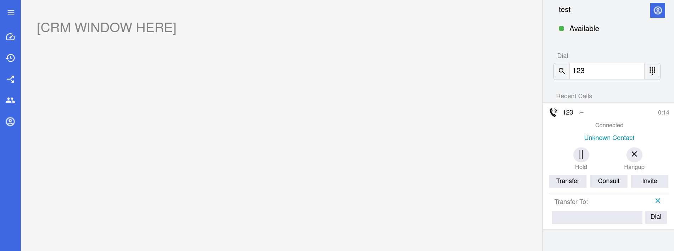

# Conclusion

There is strong goodwill to integrate the GBV and VAC helplines on the 116 Toll free number as this will enable the Ministry to have better data Nationwide and help with decision making which will effectively mean faster responses to case of Gender Violence and Violence Against children cases.

The existing infrastructure and the current system provide a perfect platform to upgrade the system and to do this integration. Eventually we expect that the volume of calls and cases at the helpline will increase exponentially.

To make this process effective the Ministry of Gender Labor and Social Development together with the partners will need to invest more on recruiting more resources to handle these increased communications as well as provide training to all stakeholders both at National Level and District Level.

With all the stakeholders working together we believe that the consultant will successfully deploy the envisaged system in the timeframe provided of 50 days.

# Appendix 1: Proposed Web-Online Form

The following fields were proposed by UCHL for the Web Online form

**Reporter Details**

What is your name? (Text Field)

Enter your contact phone number (Text Field)

What is our preferred Language? (Drop down of all languages)

Reporter Sex (Radio button for Male, Female, Hermaphrodite, Unknown)

Reporter Age Group (Radio Button for 0-4, 5-9, 10-13, 14-17,18 and Above)

Select District (Drop down of All Districts)

Alternative Contact (Text Field)

Email Address (Text Field)

Are you the directly affected? (Radio Button for Yes or No)

**Client Details**

What is your name? (Text Field)

Client Sex (Radio button for Male, Female, Hermaphrodite, Unknown)

Client Age (Text Field)

Select Client District (Drop down of All Districts)

Nearest Landmark

Guardian Name (Text Field)

Is the person attending school? (Radio Button for Yes or No)

**Perpetrator Details**

What is the name of the perpetrator? (Text Field)

Select perpetrator sex Client Sex (Radio button for Male, Female, Hermaphrodite, and Unknown)

What is the relationship with client? (Drop down with Father, Mother, Brother, Sister, Uncle, Aunt, Nephew, Niece, Teacher, Neighbor, Other related, other not related, unknown)

Does the perpetrator share household with the affected person? (Radio Button for Yes or No)

Select Perpetrator District (Drop down of All Districts)

**Case Narrative**

Fill in the case narrative (Text Field with “Tell us a short story of what happened”)

Has the case been reported to any other organization? Drop down with At Police, In court, Convicted, Released, Unknown)

**SUBMIT**

# Appendix 2: Proposed Case Categories

## VAC Categories and Sub-categories

|  |  |  |
| --- | --- | --- |
| # | Category | Subcategory |
|  | Abuse | |
| 1. | Murder | * Child Death due to Abuse * Attempted Murder * Child Sacrifice * Abortion * Mysterious Death * Poisoning * General |
| 2. | Physical Abuse | * Corporal Punishment * Electric-shocking * Beating * Burning * General |
| 3. | Emotional Abuse | * Labelling * Witness to Violence/Abuse * Bullying * Verbal Attack * General |
| 4. | Child Trafficking | * Internal Trafficking * Cross Border Trafficking * Abduction/Kidnapping * General |
| 5. | Child Exploitation | * Child Labour - Commercial * Children used for Criminal Activity * Children used for Begging * Child Labour - Domestic * Child Labour - Bonded * Child Labour * Commercial Sex Exploitation * General |
| 6. | Child Neglect | * Denial of Education * Child Malnutrition * Child Abandonment * Child Maintenance * General |
| 7. | Sexual Abuse | * Defilement * Exposure to Pornographic Materials * Sodomy * FGM (Female Genital Mutilation) * Teenage Pregnancy * Early/Forced Marriage * General |
| 8. | Online Child Sexual Abuse And Exploitation | * Online Extortion and Blackmail * Victim of Online Sexual Exploitation * Exposure to Online Child Pornography * Victim of Online Child Pornography * Attempted Defilement * Victim of Online Child Sexual Exploitation * Online Grooming for Sexual Purposes * Unwanted Sexting * Revenge Pornography * General |
|  | Counselling |  |
| 1. | Boy/Girl Relationship |  |
| 2. | Student or Teacher Relationship | * Teacher Problems * Student in Problems with School Authority * Abortion |
| 3. | Stress/Depression |  |
| 4. | Self Esteem |  |
| 5. | Reproductive Health Issues |  |
| 6. | Loss and Grief |  |
| 7. | Career Guidance |  |
| 8. | Juvenile Delinquency |  |
| 9. | Family Issues | * Divorce/Separated Parents in Conflict * Sibling Relationship * Family Member in Conflict |
| 10. | Parent or Child Relationship | * Unmanageable Children |
| 11. | Parental Guidance | * Positive Parenting * Coping with Single Parenthood |
| 12. | Peer Influence |  |
| 13. | HIV Counselling |  |
| 14. | Child Custody | * Institutionalization * Adoption * Paternity/Maternity Rights |
| 15. | Child In Conflict with the Law | * Child Imprisonment * Juvenile Delinquency * Child to Child Sex |
| 16. | Marital Issues |  |
| 17. | Addiction | * Drugs * Smoking * Alcohol * Gambling * Gaming * Pornography * Social Media/Internet * Food * Masturbation |
| 18. | Mental Issues |  |
| 19. | Legal_Issues | * Child in need of representation * Child Witness * Law in Conflict with Children's Rights * Child in Conflict with the Law * Child Imprisonment * Child Imprisoned with adult Person * Pre-Trial Briefing |
| 20. | Child to Child Sex |  |
| 21. | Lost Child | * Seeking shelter * Missing Child * Homeless Child * Lost Child |
| 22. | Life Skills |  |
| 23. | Property_Rights | * Inheritance issues * Property grabbing |
| 24. | Differently_Abled_Persons | * Deaf * Visually Impaired * Mental Disability * Physical Disability |
| 25. | Orphans | * Child headed families * Orphan in need of care and support * Orphan in need of school fees * Orphan living with elderly person * Orphan living with HIV-Infected person |
| 26. | Street Child |  |
| 27. | Discrimination | * Age * Ethnicity * HIV/AIDS * Marginal/Vulnerable Groups * Criminal Record/Ex-Prisoner * Access to Education |
| 28. | Run Away Child |  |
|  | Medical Aid | * In need of medical assistance * Access to health care * Concerns about illnesses |
|  | Information Inquiry | |
| 1. | Pre-trial Briefing |  |
| 2. | Inquiry on Other Services |  |
| 3. | Information on Helpline Services |  |
| 4. | Financial Aid |  |
| 5. | Employment/Job |  |
| 6. | Topical Issues (Child rights, Biology etc) |  |
| 7. | Case Update |  |
| 10. | Birth Registration |  |
| 11. | Appreciation |  |
| 12. | In Need of School Fees |  |

## GBV Case categories and Sub-categories

|  |  |  |
| --- | --- | --- |
| # | Category | Sub Category |
| 1. | Physical violence | * battering and beating * punching * kicking * whipping, or beating with an object * strangling * suffocating * burning intentionally * threatening with a knife, gun or other weapon. |
| 2. | Sexual violence | * Rape * Child sexual abuse * Defilement and incest * Sexual assaults * Sexual harassment * Forced prostitution * Trafficking in persons |
| 3. | Harmful traditional practices | * Female Genital Mutilation, * Early and forced marriages * Dowry related violence. |
| 4. | Economic violence | * Denial of assets and economic livelihoods * Child Neglect |
| 5. | Emotional and psychological | * verbal abuse * humiliation * confinement |
| 6. | Online Sexual Abuse & Violence |  |
| 7. | Murder |  |
| 8. | Others |  |

|  |  |
| --- | --- |
| By signing this document, I acknowledge that I have received stated deliverables to the agreed quality levels. | |
| **Min of Gender: ICT Manager**  **Contact:** Emmanuel Yeka  **Email:** [**emmanuel.yeka@mglsd.go.ug**](mailto:emmanuel.yeka@mglsd.go.ug) | **Signature:** |
| **Date:** |
| **Bitz IT Consulting Ltd: Director**  **Contact:** James Nganga  **Email:** [james.nganga@bitz-itc.com](mailto:james.nganga@bitz-itc.com) | **Signature:** |
| **Date:** |